FINAL EXAMINATION
TIME ALLOWED: 90’
Subject: Linear Algebra. No books allowed.

1/ Determine all complex numbers such that 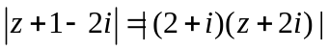.

2/ Find the matrix such that 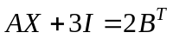, where 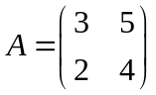 and 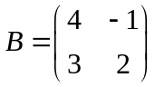.

3/ Solve the linear system 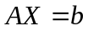, where 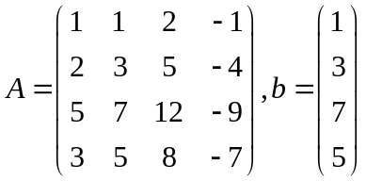.

4/ Let 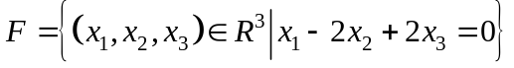 be a subspace of a vector space 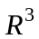.
Find one basic and a dimension of the subspace .

5/ Given an inner product in as follow:
.
Find the angle between two vectors 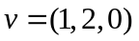 and 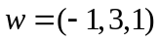.

6/ Let 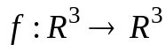 be a linear transformation.
Assume that .
a/ Compute 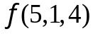.
b/ Find a dimension and one basic for Kerf.

7/ Diagonalize (if possible) the matrix 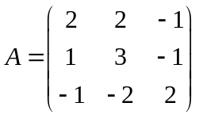,
( The characteristic equation of the matrix  is 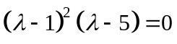)

8/ Make a change of variables that transforms the quadratic form
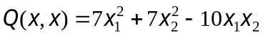 into the canonic form (using the orthogonal diagonalization method).

-----------------------  -----------------------

